The dyspneic cat

Dr Céline Pouzot-Nevoret
Assistant professor, PhD, Dipl. ECVECC
SIAMU, ICU VetAgro Sup
France

Assessment and emergent treatment of the dyspneic cat is often considered one of the most
difficult tasks of the emergency clinician. Underlying causes of shortness of breath can vary
considerably, and must often be decided with only a history and a brief physical examination. Understanding the diseases that can lead to shortness of breath and application of a few helpful guidelines can help the clinician rule out certain common disease processes and initiate prompt life-saving treatment. In general, management of the dyspneic cat consists of emergent treatment, emergent complementary exams followed by diagnostics when the clinical state has stabilized.

Emergent treatment

Telephone triage

The breathing difficulties in a cat are sometimes difficult to see, and can only appear in particular situations (stress for example). Thus, any cat whose dyspnea is visible by the owner must be the subject of immediate consultation. It may be interesting, in cats with a known chronic disease, to advise the owner to administer an additional dose of his treatment (eg, furosemide in congestive heart failure, corticosteroids and bronchodilator in known asthma).

At admission

When a dyspneic cat is admitted to the clinic, limitation of stress should be your goal number one. Indeed, this patient is not only stressed by his breathing difficulties, but also by the drive and the arrival in a new environment. Although it is often tempting to perform a complete physical examination and intravenous catheter placement, these seemingly benign interventions can result in abrupt decompensation and death, even with correct oxygen supplementation.
A dyspneic cat "pleasant and calm" after the drive and a complete physical examination by a stranger is usually severely depressed. In addition, since the cat is usually transported in a cage, signs of serious illness that would have been evident in a dog (eg unable to walk, shallow breathing) cannot be seen in a cat sitting in the darkness of a cage. Thus, the patient can be falsely evaluated as stable. Note that unlike dogs, open mouth breathing in cats is almost always pathological.
The key points in the management of a dyspneic cat are oxygen therapy performed in a non-stressful environment, while limiting manipulation. The best options for oxygen supplementation in a cat are flow-by at admission, rapidly replaced by the oxygen cage. The oxygen cage allows the cat to move freely and gives him some protection against the noise and stress of the emergency room, waiting for the treatment put in place to take effect. Nasal probes are a good choice too, but the stress induced by the insertion of the catheter (compression, xylocaine spray into the nostril, introduction of the catheter into the nostril), as well as possible sneezing, can be fatal.
For more details about oxygen therapy, please see the proceeding on advanced oxygen therapy.

A sedation on admission with Butorphanol (0.2 mg / kg SC, IM or IV) is very interesting in the dyspneic cat because it will facilitate handling, reduce the oxygen demand of the animal, slow down its respiratory rate and thus improve gas exchange.

What can you learn from your physical examination?

The therapeutic decision can sometimes be challenging because many diseases are clinically expressed in the same way and the complementary examinations are often impossible to do without endangering the life of the animal. Thus, the therapeutic decision will no longer be based on a cluster of clinical suspicions.
Additional information can be obtained both from a history and a very brief physical examination. Information relating to previous medical conditions and duration of respiratory signs are helpful. For example, knowledge of a previous history of cough would support the possibility of asthma, while prior identification of a heart murmur or treatment for heart disease would suggest congestive heart failure. Other than observation of respiratory pattern, the two most important components of a physical examination include the temperature and auscultation.
The therapeutic approach of a dyspneic cat should be based on the main diagnostic hypothesis that results from clinical examination and history.

There are many pathological processes that can lead to respiratory distress. The causes of respiratory distress are generally divided into eight categories depending on the source of the distress: (1) upper airways disease, (2) lower airways disease, (3) parenchymal disease, (4) pleural space disease, (5) thoracic wall abnormalities, (6) pulmonary thromboembolism, (7) abdominal distension, and (8) non-respiratory conditions mimicking respiratory distress.
The most common causes of dyspnea in cats are cardiac dyspnea, bronchial abnormalities, pleural cavity involvement, or upper airway obstruction. Observation of the respiratory pattern associated with a rapid physical examination is essential to help the clinician in his diagnostic procedure.

Recognition and treatment of specific condition

Upper airway obstruction

As stated previously, cats with upper airway obstruction frequently have a pronounced inspiratory effort, and may have striderous breathing. Nasal discharge may or may not be present, and chest radiographs are typically normal. Even more than with cats in respiratory distress, a low stress environment and minimal handling are a must.
Emergent treatment including sedation and capture of the airway (intubation or tracheostomy) may be required. Following sedation, a quick upper airway examination can be performed, and oral intubation can be attempted. In the presence of a foreign body or a laryngeal mass, oral intubation can be difficult to perform and a tracheostomy may be necessary. If emergent treatment is not required, sedation and an oral examination should be performed in a controlled setting, with all materials needed for intubation and tracheostomy tube placement available. In general tracheostomy tubes are challenging to manage in cats due to the production of secretions and a small tracheal lumen leading to increased airway resistance. However, it can be a lifesaving procedure, and should absolutely be performed if indicated.
Causes of upper airway obstruction include nasopharyngeal polyps, laryngeal masses, laryngeal paralysis, and upper airway swelling of other causes.

Parenchymal and lower airways diseases

Differentiation between parenchymal disease and lower airways diseases may be complicated on a dyspneic cat. The most common cause of parenchymal disease is congestive heart failure. Neoplasia and infection are less frequent. Aspiration pneumonia could occur but in a specific context (vomiting, coma…).
Infectious bronchopneumopathies are rare in cats, but more common in young cats. The pathogens most commonly implicated are Bordetella or Mycoplasma species. Mycoplasma spp. has been reported as a major cause of pneumonia in cats. Bronchopneumonia secondary to inhalation of a foreign body or bite should also be considered. During infectious bronchopneumonia, it may be interesting to look for immunodepression secondary to FeLV or FIV.
Cats with bacterial pneumonia usually have other systemic signs in addition to respiratory signs: marked abatement, anorexia, hyperthermia ...

Some tips could help the clinician to differentiate between heart failure and asthma:
- Cold cats have heart failure:
Other findings that may lead to heart failure suspicion are cardiac murmur and gallop rhythm, jugular distension and pulmonary crackles. Thus, the demonstration of hypothermia associated with a cardiac murmur and a mixed dyspnea with the presence of crackles should lead to the initiation of a rapid treatment of congestive heart failure with furosemide injections (2 mg/kg IM or IV). Ultrasound evaluation of left atrium’s size is a good way rule in or rule out heart failure. A left atrium (LA) diameter > 12 mm or a left atrium/aorta (Ao) ratio > 1.5 on the right parasternal short-axis view indicates enlargement.

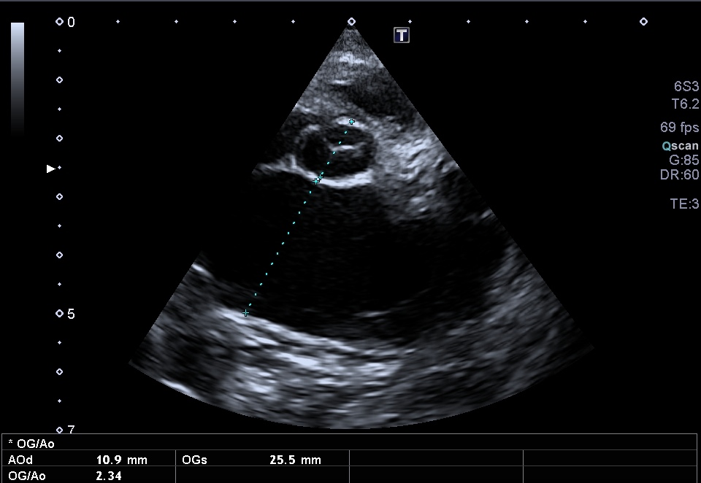
LA
Ao

SNAP NT proBNP is useful if imaging results are unclear. Indeed, plasma and pleural effusion NT proBNP have been showed to be higher in cats with cardiac failure than in cat with non-cardiac cause of dyspnea.

- Old cats don't get new onset asthma:
Airway disease in cats is a middle age cat disease. Cats may cough their entire lives, but barring lifestyle changes (e.g., moving to a different climate or with a smoker) they should not develop cough as geriatric cats.
A cat with a cough presented for a mainly expiratory dyspnea with the presence of wheezing at the pulmonary auscultation should direct the clinician towards this disease. However, it is sometimes difficult to clinically differentiate asthma from cardiogenic or parasitic respiratory distress.
Physical examination abnormalities include cough, dyspnea, and crackles, and wheezes in the pulmonary tissues. Increased bronchovesicular sounds may be the only abnormality noted on auscultation. If dyspnea occurs, it commonly has a pronounced expiratory component. Open mouth breathing or panting commonly occurs during periods of stress.
While vomiting is a common historical finding, particularly of asthma, this clinical sign can often be confused with coughing in cats.

Since all treatments for asthma (corticosteroids, bronchodilators) can be administered subcutaneously, intramuscularly or inhaled, it is not recommended to use a first-line venous route (stress limitation).
Bronchodilators are a key component of therapy for cats experiencing bronchoconstriction. Indicators of bronchoconstriction on physical examination include wheezing, expiratory distress, and significant “abdominal push.” Short-acting bronchodilators should be chosen in emergency situations; beta-2 adrenergic agonists are the most widely utilized. Anticholinergic options, such as ipratropium bromide, are also available but less commonly used. Combination of albuterol and ipratropium bromide has been reported to be synergistic and can be administered as a metered-dose inhaler, using a spacer designed for cats or nebulized.
Alternatively, terbutaline (0.01 mg/kg IV, IM or SC) can be administered easily and with minimal patient handling. Glucocorticoids at an anti-inflammatory dose (Dexamethasone 0.1 mg/kg SC) may be required in these initial stages to address airway inflammation.

Pleural space disease

Pleural cavity diseases cause a decreased tidal volume leading to a restrictive breathing pattern and paradoxal breathing, associated with dull lung sounds. Fluid and air in the pleural space can be diagnosed rapidly with point of care ultrasound (POCUS) (See Dr Boysen proceedings).

Once liquid or air in pleural space is confirmed, a thoracocentesis should be performed immediately. Thoracocentesis is both diagnostic and therapeutic, and must be performed before any further examination (chest X-ray in particular) especially when the animal is unstable.
For further details, see proceeding “Dealing with pleural effusion”.

References are available upon request.

